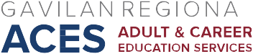

AB 104 Consortium Meeting
March 3, 2017
Agenda

- Approve February 10, 2017 minutes

- Updates/Announcements
- Preliminary Allocations Schedule, 2017-18, 18-19
- CFAD/Annual Plan modifications
- CASAS training, Workforce Institute
- CTE discussions
- Other

- Discussion of Joint Professional Development Symposium, June 2017

IV. Discussion of CLASP survey

V. Preliminary Discussion, 2017-18 funds

Next Meeting: Friday, March 17, 2017, HRC 101

